Introduction

1. How to introduce oneself as a developer in a interview?

--> https://www.themuse.com/advice/tell-me-about-yourself-interview-question-answer-examples

Hello my name is Anemish, I am a currently working as a full stack developer as Cosmitude Pvt limited. I have been working in Cosmitude, right I after I graduated from the B.E. I wanted to learn and explore new technologies so I got into a start-up and i got a lot of opportunities to do the same as we were shorthanded I had to learn and research the technologies for the product.

It was quite challenging as I had to learn many new concepts and technologies regarding Angular, python to continue developing the existing product. I also faced a lot of challenging situations where I had to brain storm the issue with my colleagues to find a solution for the issue. I am also familiar with Docker concepts and able to deploy a fully scalable secure product on a Kubernetes service with continues integration.

2.How to emphasise and the show the value of working in a start-up

--> I can emphasise the skills that I developed when working in a start-up

Self-learning skills

multi-tasking

flexibility and adaptability

resourceful

3.Can you find the companies with my requirement

-->

Yes, I was able to find companies with my requirement, I noticed that there was also a demand for

fornt end - React JS which is an another frame work similar to Angular.

4.Skills that need to be studied

Relational database

React JS

Design patterns

Homework

1. Identify the important Job skills, the activity and how to get the required skills (exp or training), identify the skills for the road map

-->Skills for full stack developer 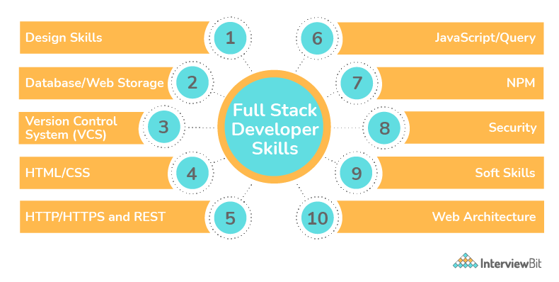

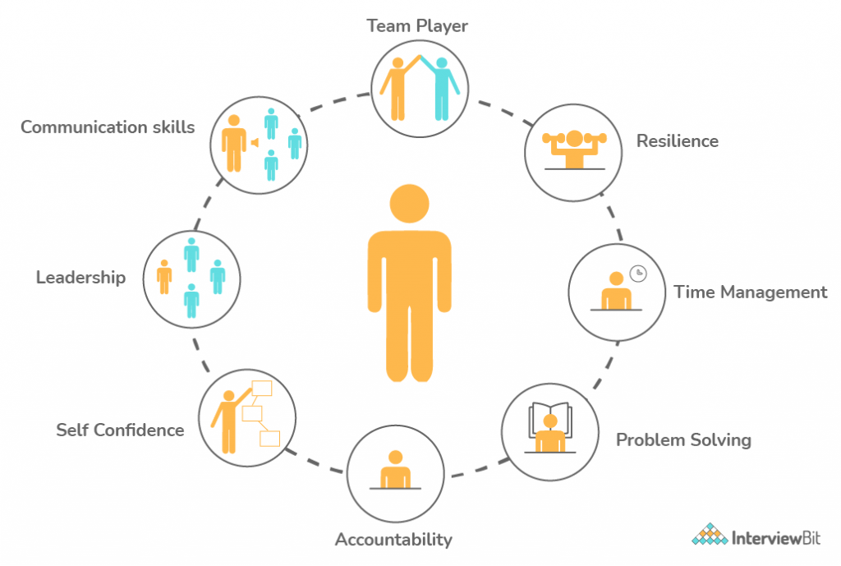

2. Road map of a SD and web application developer

* --> **Junior Software Engineer**: At the beginning of your career you’ll have limited experience and start in an entry-level position. As a junior software engineer, you’ll be required to develop software to meet client requirements within a specified time frame. You’ll report to your team leader, who will act as a mentor and guide you. During this period of your career, you have the opportunity to learn new skills and gain essential experience working on real-life software projects.
* **Senior Software Engineer**: After a few years, you’ll become a senior software engineer. You’ll learn new programming languages, and master the software development lifecycle. You may have the opportunity to train junior engineers or even manage a small team of your own. You’ll start to be introduced to other business elements such as project budgets and high-level company objectives.
* **Tech Lead**: As a tech lead, you’ll be responsible for the entire software development process. You’ll manage a large team of professionals involved in software design and development. You’ll be required to report development progress to company stakeholders and provide input into the decision making process.
* **Team Manager**: If you have strong leadership skills, you can progress into a managerial-based role. You’ll be responsible for the wellbeing of the entire team and will oversee their career progression.
* **Technical Architect**: As a technical architect, you’re expected to overlook the entire architecture and technical design. You’ll be required to build processes for the team and provide technical leadership. This role will also involve looking into the scaling of support systems.
* **Chief Technology Officer**: A CTO is the head of an organization’s technological needs. They oversee R&D and employ technology to improve products and services for their clients. This is often considered the pinnacle of a software engineer's career.

3. how to get the required skills (exp or training)

--> the Skills needed for the job needs both training and experience to require the developed skill.

4. are you getting this in your current job?

🡪 I was able to experience front end, back end, design and dev ops in the current job. I also have first-hand experience in project management as I had taken up the role of a scrum master.

5. what are most common questions in your interview

I have gone through a lot of different web sites each emphasizes different aspects

* Soft skills
* Technical questions